Guangzhou Stars Electronics Technology Co., Ltd
—— A Brief Introduction of PMP-T80
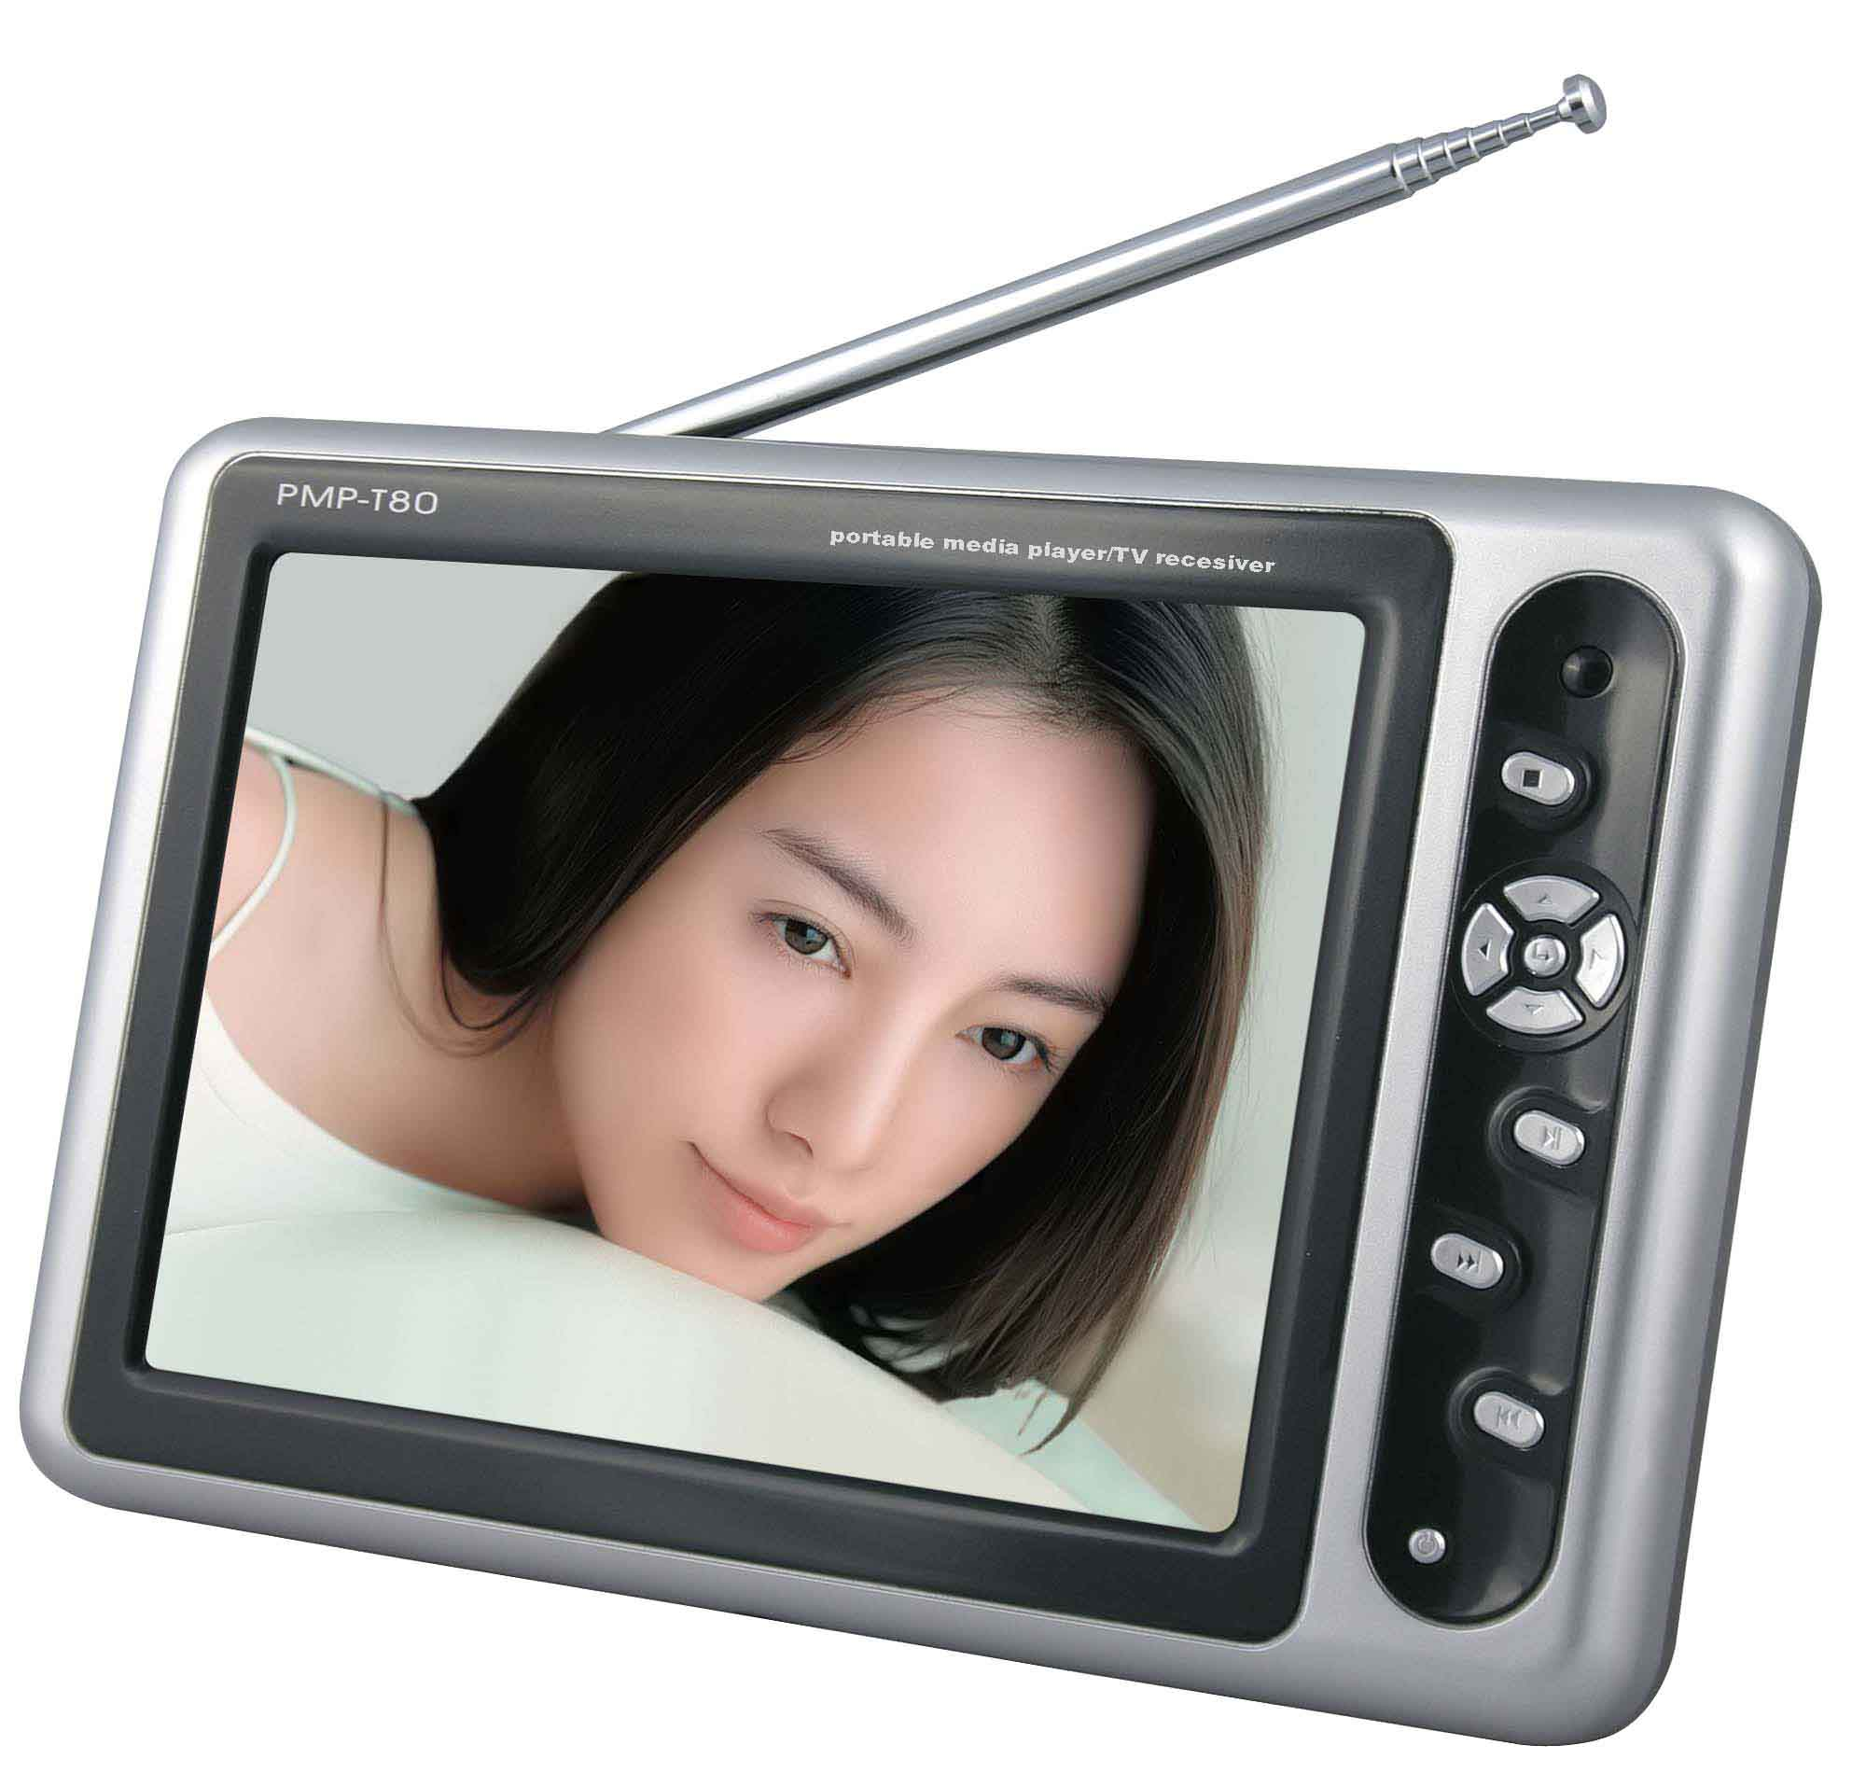
(PMP-T80)
Ⅰ. Features:

A. The world's first PMP(MPEG-4) player with high clear digital circuit applied in. High clear and vivid picture quality （in VGA）brings you amazing visual enjoyment.
B. The world's first PMP(MPEG-4) player with 8-inch (biggest size for PMP up to now) high resolution LCD digital display.
C. SEVEN-IN-ONE Functions: MP4 Mobile Theater/MP3 Player/Digital Photo Frame/LCD TV/Mobile HDD/Digital Partner/AV input & output
D. The most advanced DIVX/DVD/DOLBY decoding technology: able to decode formats as DIVX, XVID, MPEG4, DVD, VCD, SVCD, CD-DA, MP3, JPEG, etc. No format conversion but a guaranteed direct, smooth and easy playback.
E. USB2.0 High Capacity HDD (20G/40G, UP TO 120G).
F. USB2.0 High Speed Interface.
G. SIX-IN-ONE Card Slot: Compatible with SD, MMC, MS, XD, MS-PRO, RS-MMC, and supports direct transfer of files from card(s) to hard disk.
H. All-Channel TV Receiver (PAL/NTSC), with both AIR TV & CABLE TV signals available.
I. FM Transmitter, transmitting audio signals to your car audio wirelessly.
J. 8-metre Remote Control.
K. Supply (charging) power by car power adaptor as well as home power AC adaptor, and a special bracket is optional for in-car installation.
L. In-Built Rechargeable Lithium Battery.
M. Super-slim streamline frame design matched with silver/grey color makes the player fashionable-looking and elegant.
N. User-friendly operation design. Files can be copied, deleted, renamed, and property-displayed.
O. Software upgrading is supported.

Ⅱ. Specification:
Model: | PMP-T80
Frame Size: | 230mm(W)×163mm(H)×28mm(T)
Way of Control： | Press Button, Remote Control
Power Supply： | Build-In Rechargeable Battery, AC Adaptor
Storage Media： | Hard Disk, 6-in-1 Card Slot
Way of Carrying | Portable

Ⅲ. Applications & Market Positioning
ⅰ. Applications：
1. PMP-T80 is a high-end digital product combined with various functions, applicable to a wide range of field referring to home appliances, car electronics, learning, traveling and gift markets.
2. Its big screen and portability qualify PMP-T80 to be a home appliance, adding sparks to your lifestyle. Whether it is put in your living room or bedroom, you have TV, DVD or VCD player all around you. Beside convenience and fashion, PMP-T80 possesses many practical functions. For example, through its AV input port, you can send signals to your camera device, when PMP-T80 turns to be a mobile monitor. Watching movies or listening to music, it’s all up to you.
3. To people “on the wheels”, PMP-T80’s fashionable design and practical functions are performed to the maximum. Imagine watching movies or listening to music in high quality in your car, what a pleasure! But be careful not to watch video files when driving. The special auto charger assures continuous power supply as long as your engine is turned on. PMP-T80 will surely surprise your family and friends at your get-together.
4. PMP-T80 is also a good helper to students facing more and more learning materials. With a super-capacity HDD, PMP-T80 can help to contain all these learning materials for you. Why not watch a video or listen to your favorite music at intervals when studying? Come on, learning can be an enjoyable thing.
5. The top-grade PMP-T80 will surely make you the envy of people around you with its fashionable design and practical functions. It would be a bigger pleasure to share your joys with them. Present a PMP-T80 to a friend at his/her birthday party, or to your partner after a business meeting, they will be surprised.
ⅱ. Market Positioning:
New technologies are really developing at an amazing speed, and only a few years ago, MP3 began to appear and soon dominate the market with its mini-size and convenient features. Nowadays, the trend of substitution continues to spring up in the digital market. MP3 is already generally considered to be a substitution of cassette and CD player, and it is bound to be replaced by a more advanced portable player itself due to lack of video support. With a combined function of audio and video playback, the new portable player can be called a personal digital entertainment terminal, the representative of which is the booming PMP(MP4) player. Its huge market potentials attract more and more manufacturers to join in with an attempt of market share. As a player helping to improve life quality, MP4 is expected to be the future digital leader, especially when its practicability, personalization, upgrade and other functions have been enhanced.
After 2 years’ market survey and technological research, Stars Corp. began to show its PMP-T80 on the market since September 2006. With foreseeing product design and market positioning, PMP-T80 excels in many respects such as various functions and applications. Stars Corp. further makes it more acceptable to customers by reasonable management of price system and sales mode. Our main target consumers are fashion pursuers, car owners, gift-senders and household users around the world. And we’d like to distribute our goods through reliable traders, wholesalers and retailers.

