LS-519 instructions

Ls-519图片：
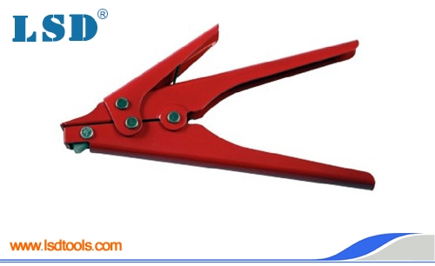

- Applicable width:2.4~9.0mm
- Application: for fastening cable and wires quickly,cutting left parts by manual
- Function:fastening cables and wires
- Length:195mm
- Weight:0.3Kg
Thank you for your inquiry. Would you tell us what quantity you require so that we can work out the offer。

Editor:Rose 2010-10-26

