Dongguan Weixin Electronic Technology CO., LTD.

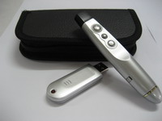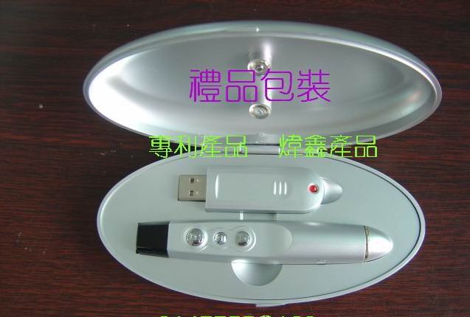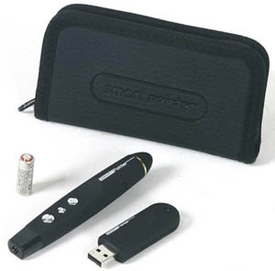
(SP-100 Remote Control Laser Pointer)
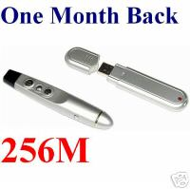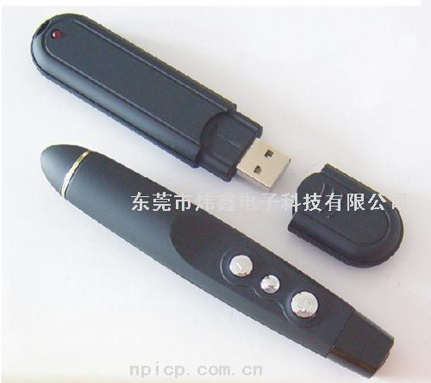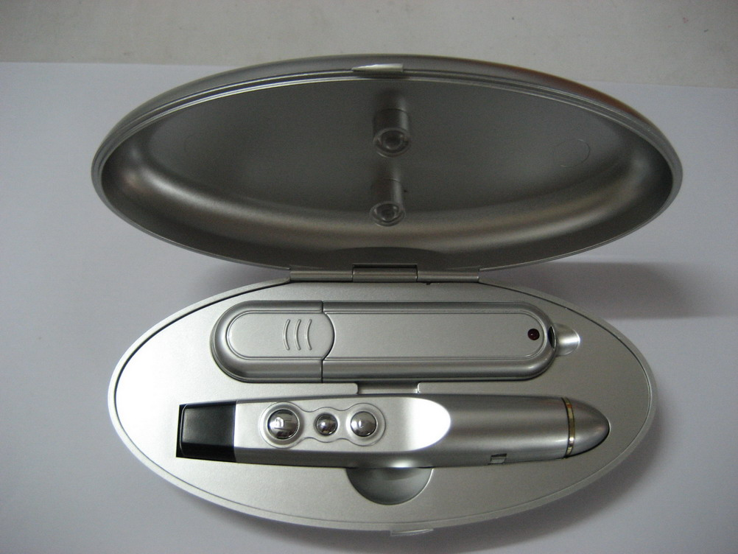
(SP-150 Laser Pointer with 128/256/512MB/1/2G Flash Memory)
- The Smart pointer has the function of not only the existing laser pointer but also remote page-up and page-down.
- The page-up and page-down of slides can be remotely control 15-meter range.
- The Smart pointer simply works without any installation of driver.
- The Smart pointer is practically designed with new concept such that it can be conveniently used.
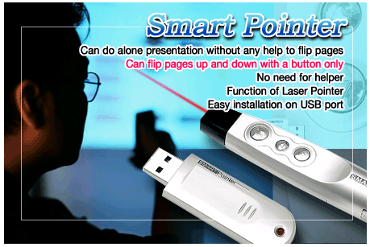
- Simply works without any installation of program (Plug and Play)
- Works with any computer that has a USB port
- Low power consumption and remotely controlled within the range of 15 meters
- RF propagation solving a directional problem in infrared propagation
- Gives multiple user-identification numbers for multiple concurrent users keeping from nterference

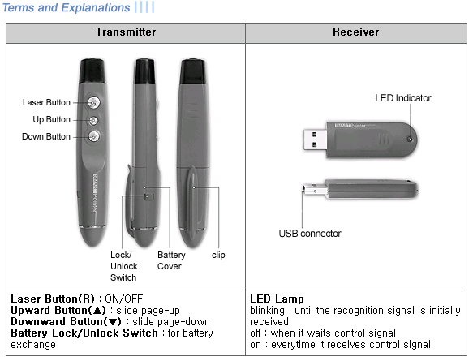
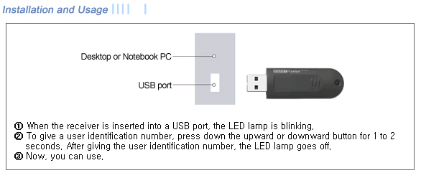
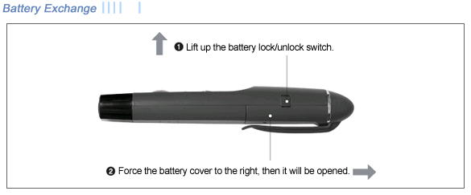
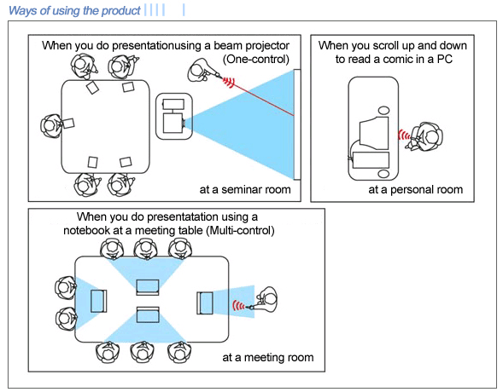

Dongguan Weixin Electronic Technology CO., Ltd.
Address: Jiuwei Zone Qishi Town
Dongguan City 523508
China
Homepage: www.dgweixin.com
Contact person: Christy
Tel: 86- 0769-86726663-808
Fax：86-0769-86666218
Email:christy4541808@163.com
MSN: christy4541808@hotmail.com
Skype: christy4541808

