LPF series float ball water level controller
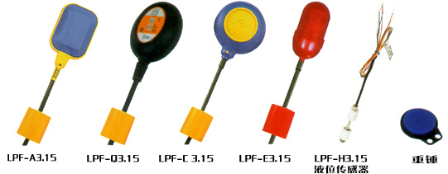
- Installation method of weight hammer
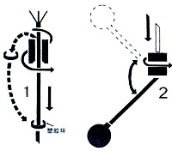
- Put the cable wire of ball switch through the below fovea round hole of weight hammer, and push the weight hammer lightly, and the teething ring at the top fovea round hole shall fall off, (if necessary, you can use screw driver to remove the ring), then put the ring to the cable where you set the water level point. (see the picture 1 at the right)
- Push the weight hammer lightly to pull out the cable wire, till the hammer center is fastened to the teething ring. ** Once the hammer is fastened to the ring, it won’t drop down. If the ring is damaged or lost, you can use naked copper wire with same diameter to replace with.
- When using, you had better use a copper wire or other thing to fix the weight hammer to the cable or inner wall of case, (locked at up and down ends), for fear that the hammer glides to affect the water level control.
- Please draw the cable wire to the control box directly, and avoid of using middle tie-in; if no way, you mustn’t put the tie-in into the water.

- Performance and feature:

The LPF-type float ball controller is a switch which can adjust the liquid level at the barrel, groove or well. It can be adjusted automatically, and easy operated and installed, safe and secure, innoxious and green, free from maintaining. It has resistant function to the polluted water. The product has passed the inspection of Zhejiang province industrial produces inspection center, subject to Q/QLP001-2002 standard, which is widely used in the vessels such as pond, barrel, groove, can filled with water, oil, weak acid and weak alkali for family of factory and mine. If you connect two controllers in series, i.e. one is put into pond, the other is put to the well for controlling the pump, for fear that it shall damage the pump equipment caused by opening empty pump because of water shortage.(see picture 3). Also you can connect three controllers in series, one is put to water tower, one is put to filtrating pond, and one is out to river or well, which can control two pump equipments at the same time. (Refer to picture 3).

III. Technical index:
Rated current, voltage: 10(8A) 250V~10(4A) 380V;
Working temperature: -10℃~80℃
Control range: ≥0.2M
Working life: ≥50000
Wire length: 3M, 4M (if special, specially done)
Iv. Installation and connection method
