JF15B、TP8B16（DHC15B）rail type timer
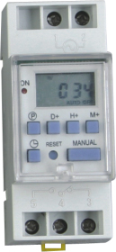
JF15B、TP8B16（DHC15B）rail type multi-function, programmable timer

Description:
1. Installed with 35mm standard rail, small and smart, substitute for KG316T;
2. Control at real time, preset time circulation in 7 days or 24 Hrs;
3. One-way put-out, 8 On/OFF time setting, 10 date groups;
4. Time-control : Max 168Hrs, Min 1min;
5. LCD shown, with high capacity chargeable battery in support, work normally when power cut;
6. Alternation in 12/24 Hrs, default as 24 Hrs.

Type
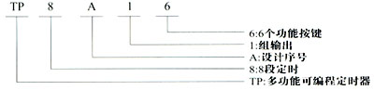
Technical index:

Rated voltage:  AC220V±10% 50Hz | Contact No.:  1 group transformation | Time error:  ≤2s/day（25℃）
ON/OFF No.:  8 ON and 8 OFF | Power consumed :  4.5VA（max） | Time range:  1min~168Hrs
Time-keeping of power cut: ≥15days after charging for 18 Hrs continually |  | Min time-keeping: 1min
Contact capacity: resistant load: 16A/250VAC（COSφ=1）;  Sensible Load: 2.5A/250VAC（COSφ=0。6）;  Lamp power: 1000W |  | Electric life: 100000 times  (Rated load)  Mechanical life: 100000 times
Environment Temperature:  35～85%RH | Working Temperature:  -10～55℃ | Weight:  125g
Operation instruction
- Begin using the timer, please put through the rated control power source, and then press the return key “RESET”.
- Setting the timer at first time, if you want to change 24-hour type to 12-hour type, please press the key “” for 5 seconds, and the LCD will show “AM’; If you want to change to 24-hour type again, please press the key“” for 5 seconds, it returns.
- Program setting
Step | keys | Program content
1 | Press “P” | Show“1_{ON}”,appear “”，to set first time group ON；
2* | Press “D+” | To set some day or few days ON in a week；
3 | Press “H+/M+” | To set hour or minute of specified time ON；
4 | Press “P” | Show“1_{OFF}”appear“”，to set first time group OFF
5 | Press “P” | To set some day or few days OFF in a week；
6 | Press “H+/M+” | To set hour or minute of specified time OFF；
7 | Repeat steps of 2～6 | Set 2~8 groups of time ON and OFF;
8** | Press “” | Finish the setting

Remarks:
If you want to cancel some time section, please press the key “MANUAL”, LCD will appear “－－＝－－”; Press “ MANUAL” again, will return.
- 10 types of date group models:（1.MO TU WE TH FR SA SU；2.MO TU WE TH FR；3.SA SU；4.MO；5.TU；6.WE；7.TH；8.FR；9.SA；10.SU）.
- If you don’t need 8 groups of time, please press “” to finish the setting, and return to the real clock situation.
4. Real clock setting
a. Press the key “” and “D+” for setting at the same time, till LCD shows the present week;
b. Press the key “” and “H+” for setting at the same time, till LCD shows the present hour;
c. Press the key “” and “M+” for setting at the same time, till LCD shows the present minute;
d. Press the key “MANUAL” to show “ON AUTO” or “AUTO OFF”; (If the automatic timer first situation to be ON, please choose “ON AUTO”, if the automatic timer first situation to be OFF, please choose “AUTO OFF”.
e. Pressing “MANUAL” can change situation of Open and close. “ON “means normal open, “OFF” means normal close.

Outline Size
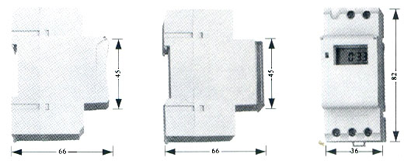
Notes:

The open and close time of the same time section shall be agreed with the date model.
Please use according to the requirements of technical index.
The product is installed with chargeable battery of high capacity, please don’t discharge and throw into the fire.

